C V

Personal profie
I am passionate and committed to give something back to the community. I have strong values built around helping others. I am extremely trustworthy, polite , respectful and I can work within a team. | 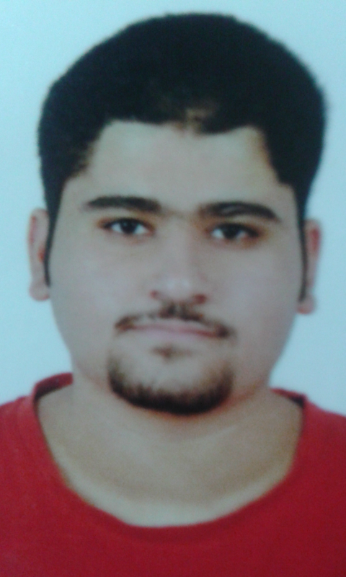

Personal Details

Name: | Jameel Abdulla Yusuf foulad
Date of birth: | 18/09/1997 | Passport No. |  | 2437294
Nationality | Bahraini | email |  | jameelnyk@gmail.com
Religion | Muslim | Contact: | 37780161
Marital Status | Single | CPR No. | 970906110
Address: | House 3307, road3668, block236, Samaheej

Education
-Withdrew from the second secondary year from Sh Khalifa bin Salman Institute of Technology, 2014-2015.

-Graduated from Samaheej Intermediat School,2012-2013

Hobbies
-Fishing
-swimming

